Social Value UK Working Group Update May 2019

Social Value Working Groups are collaborative groups led by members and supported by Social Value UK.
The Working groups are developed around engagement with a particular theme or sector and aim to raise awareness of the chosen issue/topic, both within the Working Group and externally and come together to share best practice.
The groups are set up in a variety of ways depending on the requirements of the members. Some will have an online platform, whilst others agree to meet face to face several times a year.
This document is designed to give a quarterly update on the activities of the Working Groups.
If you are interested in finding out more about the Social Value Working Groups, please contact Becca Harvey (Memberships and Networks Manager) at rebecca.harvey@socialvalueuk.org

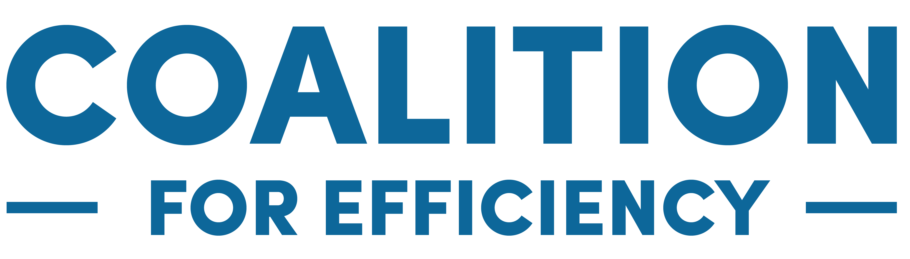
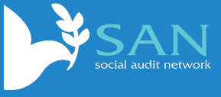
Developed Working Groups

Gender, Inclusion and Impact Management
The working group for Gender, Inclusion and Impact Management works focuses on understanding impact management and measurement in relation to gender issues and activities carried out that have an impact based on gender. The web page on SVUK has been updated with current information for the Gender group.
The next meeting to be held at the end of June
The working group has so far:
Written Gender inequality, power and accountability article. This blog illustrates the huge gender inequality and accountability gaps that exist throughout our society as has been seen in many of the recent sexual abuse scandals across many different sectors and institutions.
Hosted a National Social Value Conference Roundtable. Working group members Antonia Orr, Catherine Manning and Liz Allen hosted a roundtable at the National Social Value Conference 2019 in Manchester on 21 November. The discussion focused on the aims of the group, and the actions that have been taken and are planned for the group.
If you would like more information or to get involved please contact one of the group leads:
Catherine Manning – catherine.manning@socialvalueuk.org
Antonia Orr – antonia@cfefficiency.org.uk
Liz Allen – lizallen@theconnectives.com

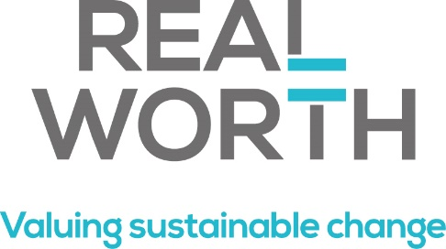

Maximising Social Value in the Built Environment
The thought leadership and working group on Maximising Social Value in the Built Environment focuses on social value and social impact progress within the built environment sector.
RealWorth are convening this working group, as their experience and work in this arena is pioneering. RealWorth work with organisations to put a price on social and environmental change and to help them achieve better, more sustainable outcomes.
The next Maximising Social Value the Built Environment meet up will be held at Multiplex offices in London on the 13th June 2019.
This event will focus on three practical steps on how to maximise social value, building on the great work already being done by contractors on training, apprenticeships, community programmes etc.:

1. Choosing to support something that affects vulnerable / hard to reach people in the local area.
2. Using local partners for delivery.
3. Collecting information from people about change

Participants will be treated to some short case studies to illustrate how each of the above steps can be implemented and the benefits that have arisen.

Developing Working Groups
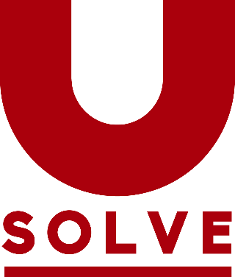
Impact Management and the Sustainable Development Goals
This newly established working group is currently writing a whitepaper on the SDGs and Impact Management. This document will include a technical mapping of the SDGs against the Social Value Principles and will explore how (if at all) different sectors are using the SDGs to make decisions and measure their impact.
If you would like to be involved with this working group, please contact:
Becca Harvey – rebecca.harvey@socialvalueuk.org

Social Value and Culture
Social Value UK are currently working alongside two of our organisational members – MB Associates and The Audience Agency – to create the Social Value and Culture Working group. The working group is currently working towards a launch event later this year (please check the website for more details).
If you would like to be involved with this working group, please contact:
Catherine Manning – catherine.manning@socialvalueuk.org

Campaign to Change the way the world accounts for value
Social Value UK are currently establishing a working group to assist SVUK in our larger campaign to change the way the financial world accounts for profit. Social Value UK are aiming to create legislative change to the way environmental and societal impact effects profit in financial accounts. This will be a long process, and we are aiming to gain press coverage, continue and extend our research and work with businesses and accountancy bodies to create real change.
If you would like to be involved with this working group, please contact:
David Thomas – David.thomas@socialvalueuk.org
Ben Carpenter – ben.carpenter@socialvalueuk.org

